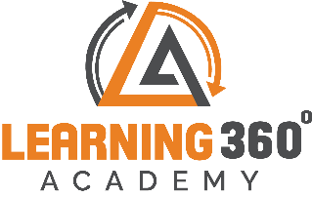
Essentials on Test Automation with Selenium
Day | Topics
1 | Introduction to Python: Environment setup, Basics
2 | Installing Python bindings for Selenium
3 | Instructions for Windows users
4 | Installing from Git sources
5 | Drivers - Downloading Selenium server
6 | Getting Started: Simple Usage
7 | Selenium to write First test
8 | Walk-through of the example
9 | Using Selenium with remote WebDriver
10 | Navigation: Interacting with the page
11 | Filling in forms
Duration: 35 Hours
12 | Drag and drop
13 | Moving between windows and frames
14 | Popup dialogs
15 | Navigation: history and location
16 | Cookies
17 | Locating Elements:Locating by Id, Name
18 | Locating by XPath
19 | Locating Hyperlinks by Link Text
20 | Locating Elements by Tag Name, Class Name, CSS Selectors
21 | Waits: Explicit Waits, Implicit Waits
22 | WebDriver API
23 | Exceptions, Action Chains, Alerts
24 | Special Keys, Locate elements By, Desired Capabilities  25 Touch Actions
25 | Touch Actions
26 | Firefox WebDriver
27 | Chrome WebDriver
28 | Remote WebDriver
29 | Color Support
30 | Selenium Based Mini Project Using Python

www.learning360.in

+91 9324993802 | Email: enquiry@learning360.in

309, 6th Floor Shivkripa Commercial, Above Waman Hari Pethe Jewellery Shop, Ghokle rd., Opp. Thane Railway Station, Thane – West P-400604

